Resume
Nayab Singh
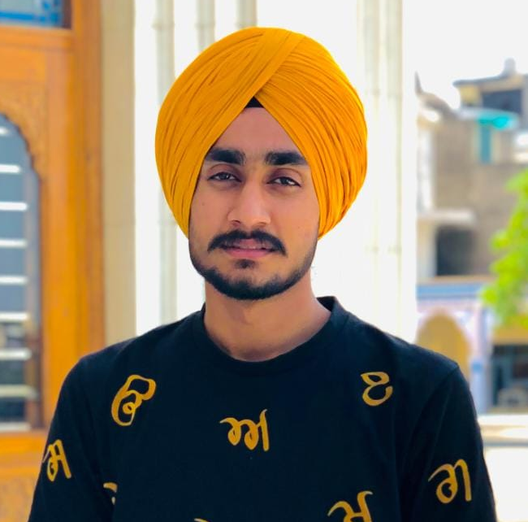
Baba bidhi chand Nagar , kabar wala road , Muktsar
Distt. Muktsar (Punjab)
Pin code:- 1502026
Contact no. 73070 35386
E-Mail- gbawaji1322@gmail.com

CAREER OBJECTIVE :-
Work Hard to the best of my ability, Set goals, Achieve them and seek individual growth as well as add value to the organization .

work experience:-
- 2+ Years experience in Rana Sugars Limited Head Office ( RSL DISTILLERIES PVT.LTD.) sector 8C Chandigarh as a Marketing Executive.

JOB RESPONSIBILITIES :-

- Maintain track of IMFL (Foreign Liquor) & CL ( Desi Liquor) sale made on monthly basis
- To provide sales target to the sales team given by Sales Head
- Tracking and maintain daily activity of the field staff
- Currently handling team of 18 members
- Co-ordination with distillery and respective L-13 to make sure they get the Liquor on time against the indent they have given to the distillery
- Travelling in Haryana as in when required to push the sale and to check the work of the team members
- Co-ordination with purchase department to ensure that the sales team get the gifts to distribute within their respective districts

SKILL :-

- Excellent communication skills
- Proficient with basic computer knowledge.
- Problem Solving Skills.
- Communication Skills.
- Teamwork.
- Organization Skills.
- Good creative thinking.
- Flexible &adaptable to work.

EDUCATIONAL QUALIFICATION :-

- Pursuing Graduation Through Correspondence

- Two year IT diploma course with 79% marks 2019.

- 12th from PSEB.
- 10th from PSEB.

PERSONAL DETAILS :-

Name : Nayab Singh

Father Name : S. Darshan singh

Date of Birth : 05 OCTOBER 1999

Sex : Male

Martial Status : Unmarried

Hobbies : Making friends and Singing

Languages Known: Punjabi, Hindi and English

“I hereby declare that the above mentioned details are complete and correct to the best of my knowledge and belief “

Date____________ (NAYAB SINGH)

